Car Pooling System
Use Case Document


 | Prepared By / Last Updated By | Prepared By / Last Updated By | Reviewed by | Reviewed by | Approved By
Name | Uttara Chhaparwal | Siddharth Jain | Sahil Shrivastava | Vaibhav Tomar | Vishakha Khare
Role | Team Member | Team Member | Team Member | Team Member | Scrum Master
Signature
Date

Table of Contents
1.0 Introduction 3
1.1 Purpose & Scope of the document 3
1.2 Intended Audience 3
1.3 Use case ‘User Registration’ 3
1.3.1 Use case attributes 3
1.3.2 Use Case Model 4
1.3.3 Business Rules 4
1.3.4 UI Requirements 4
1.3.5 UI Field Validations 5
1.4 Use case ‘User Credential Authentication’ 6
1.4.1 Use case attributes 6
1.4.2 Use Case Model 7
1.4.3 Business Rules 7
1.4.4 UI Requirements 7
2.0 Database Design 8
2.1 Tables Structure 8
3.0 Change Log 10

Introduction

Purpose & Scope of the document
- Providing the necessary inputs to the detailed requirements gathering phase and further on for the SDLC processes.

- This document also serves to establish the traceability between the Business Objectives and the requirements identified in the proposed solution and how they satisfy the stated objectives.
- Provide expectation traceability in terms of the requirements and the user expectation.
- Serves as a formal template for documenting the Business Requirements which also includes statutory and regulatory requirements.
The purpose of this document is to systematically capture requirements for the project and the system to be developed. Functional requirements are captured in this document. It also serves as the input for the project scoping.

Intended Audience
- All members of the project.
- Delivery assurance/excellence group.

Use case ‘User Registration’

Use case attributes
Use Case Description:

This use case deals with the capture of user details. The ‘user’ here shall be the operator of the system and will be keying in the Rider's information into the system.

Scope:

- User registration

Actors:

- User – the operator

Trigger:

Click ‘Save’ button in the ‘User Registration’ page

Pre-Condition:

User being able to access the homepage & get redirected to the ‘User Registration’ page upon click of ‘Sign Up’ link.

Post Condition:

User is in the Enter Ride Details page & submit details

Flow of Events:

User at homepage → Click ‘Register if new’ link → User is in the Ride Details page → User details are submitted and added onto the database

Primary Scenario:
A new user – is able to click ‘Get Started’ link and able to provide his details and get enrolled in the system.

1.3.2 Use Case Model

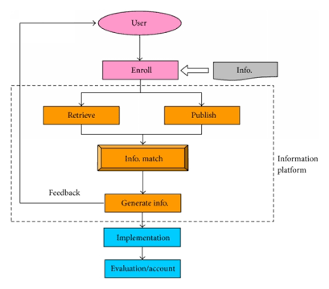

Business Rules

Business rules should be defined using the following attributes: -

- When the user clicks on the Signup link, it should re-direct to registration form.
    - User needs to fill some of the basic attributes/fields as mentioned below in requirement: First Name, Last Name, Age, Gender, Contact Number, User Id, Password, Pickup and Dro locations details and so on.
- Clicking ‘Submit’ should validate the datatype constraints for each field
- Post-successful field level validation, save the information in the database.
- Upon saving the information in the database, display the message ‘Your details are submitted successfully’.

UI Requirements
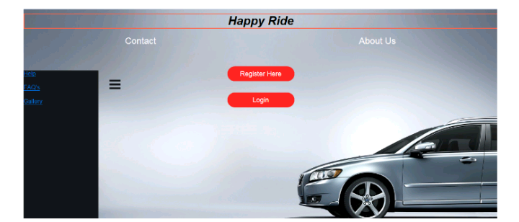
Here is a prototype on how the homepage should look like.

Here is a prototype on how the User Registration page should look like.
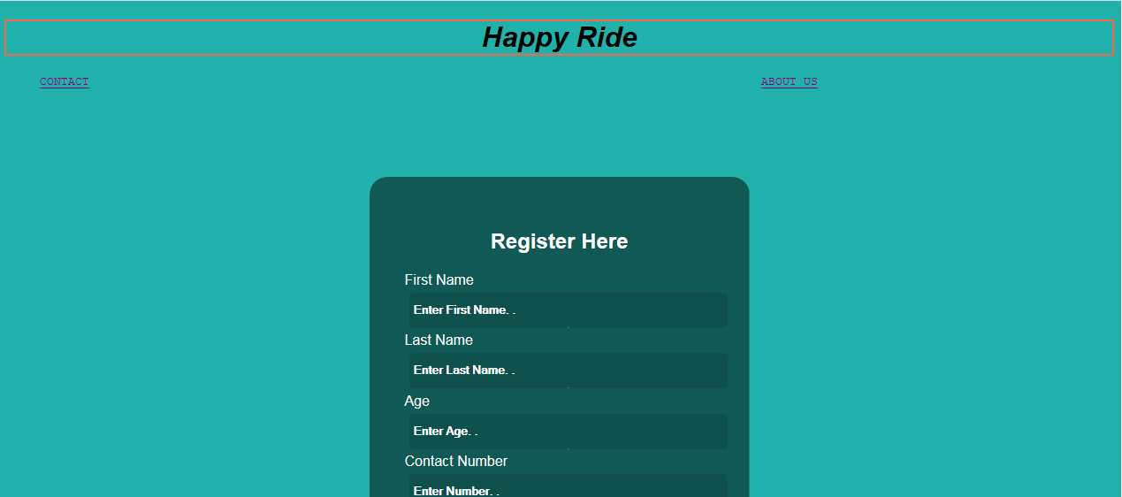



1.3.5 UI Field Validations
Please refer to the below requirements for field level validations:

- All fields are mandatory as per the validatioms applied.
- Username should be less than 50 chars.
- Password and Confirm Password fields should be the same.
- First Name, Last Name, Pick up Location and Drop Location, City should be less than 50 chars.
- Contact Number must be of 10 digits’ in length.

Use case ‘User Credential Authentication’

Use case attributes
Use Case Description:

This use case deals with the authentication of the user credentials. The ‘user’ here shall be the operator of the system and will be keying in the rider information into the system.

Scope:

- User credentials authentication

Actors:

User – the operator

Trigger:

Click ‘Login’ link, after keying in ‘UserID’ & ‘Password’ field.

Pre-Condition:

User being able to access the homepage

Post Condition:

User is in the Registration page

Flow of Events:

User at homepage → Key in ‘UserID’ & ‘Password’ field → User credentials are validated → Ride Details page is displayed

Primary Scenario:
A registered user – is able click ‘Login’ link, after keying in ‘UserID’ & ‘Password’ field and get his credentials authenticated with the existing database entry.

Alternative Scenario:
A registered user – is able click ‘Login’ link, after keying in ‘UserID’ & ‘Password’ field and unable to get his credentials authenticated. The user is presented with relevant error messages:

- Invalid User ID – ‘The UserID provided does not exist in our records’
- Incorrect Password – ‘Password provided is incorrect. Please reach out to your system admin.’

Use Case Model
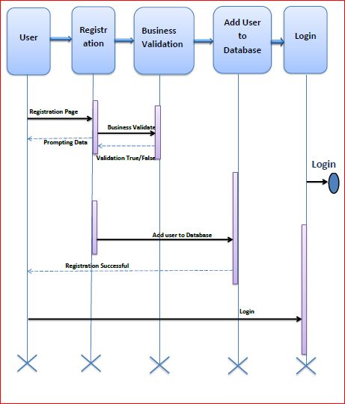

Business Rules
Business rules should be defined using the following attributes: -

- A registered user – is able click ‘Login’ link, after keying in ‘UserID’ & ‘Password’ field and get his credentials authenticated with the existing database entry.

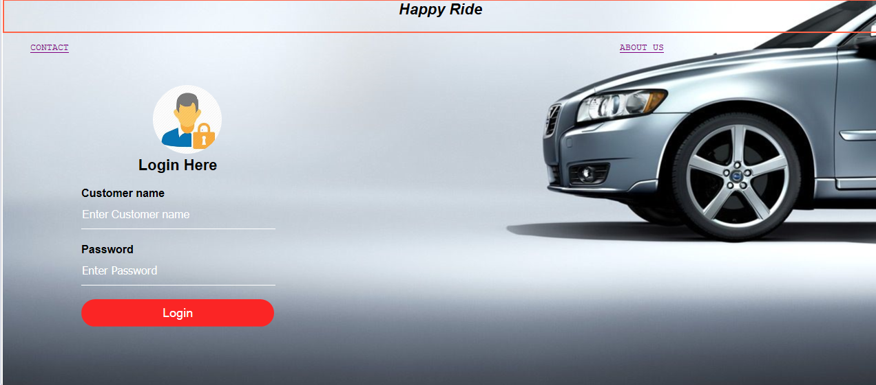
UI Requirements
Here is a prototype on how the Login Page should look like.

Database Design

Tables Structure
Student Registration:
Personal Details:
Column Name | Data Type | Length | Nulls | Possible Values
User Id | Alphabetic | 50 | N
Password | Alphabetic | 50 | N
First Name | Alphabetic | 50 | N
Last Name | Alphabetic | 50 | N
Age | NA | 5 | N | 18-120
Gender | NA | 10 | N | Male, Female
Contact Number | Numeric | 10 | Y
Pick Up Location | Alphabetic | 50 | N
Drop Location | Alphabetic | 50 | N

Address Details:
Column Name | Data Type | Length | Nulls | Possible Values
Street | Alphanumeric | 50 | N
Locality | Alphanumeric | 50 | Y
City | Alphabetic | 50 | N
State | Alphanumeric | 50 | N
Zip Code | Numeric | 10 | N

Payment Details:
Column Name | Data Type | Length | Nulls | Possible Values
Card No | Numeric | 50 | N
Bank Name | Alphabetic | 50 | N
CVV Code | Numeric | 3 | N
Card Expiry Date | Numeric | 10 | N

Change Log
Version Number | Changes Made
V1.0 | Initial baseline created on <27/03/19> by Uttara Chhaparwal
V1.1 | <Please refer the configuration control tool / change item status form if the details of changes are maintained separately. If not, the template given below needs to be followed>
V1.1 | Section No. | Changed By | Effective Date | Changes Effected

